**Send Coaching Feedback Workflow | v1**

Using the new feedback functionality

1. This is only for Agent Feedback and should ideally not be used for any other type of feedback.
2. Feedback is distributed per assessment.
3. Only one agent feedback per link will be allowed.
4. Only interactions with feedback will allow for a mail to be submitted.

You can access the feedback function from the following app options:

* Campaign Management

On the Campaign Management via the *Coaching Feedback* link.

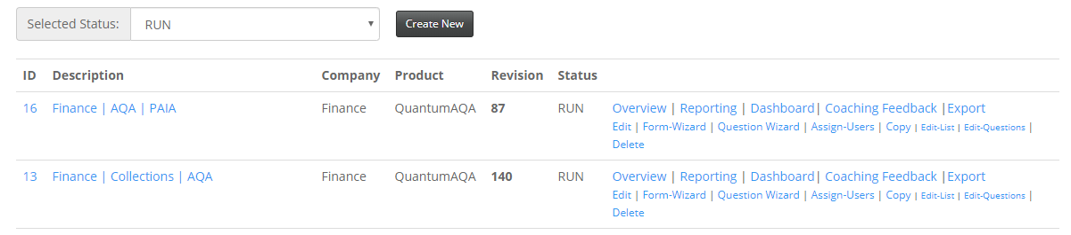

Here you can select *Review* of the assessment you require to send for feedback

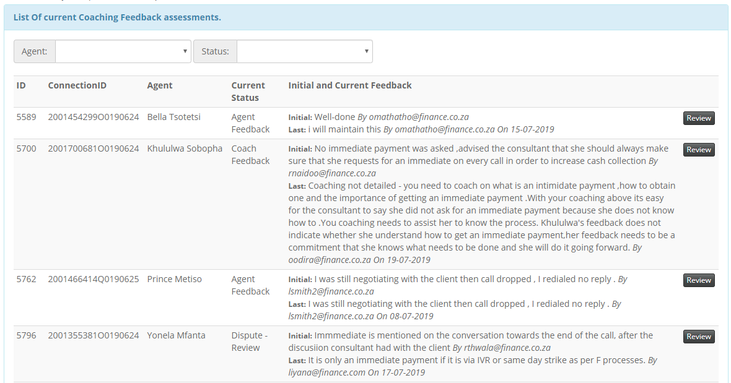

Now follow **Step 1 – 5** on Page 6…

* Performance Tracker

Access the Performance Tracker via the *Interactive Dashboard*

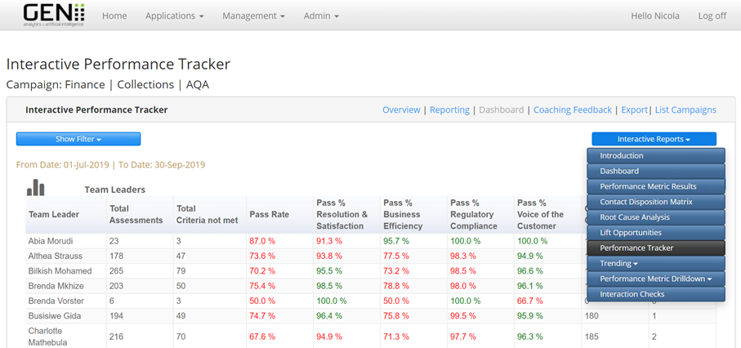

Here you can select your team or an agent and select an interaction for coaching

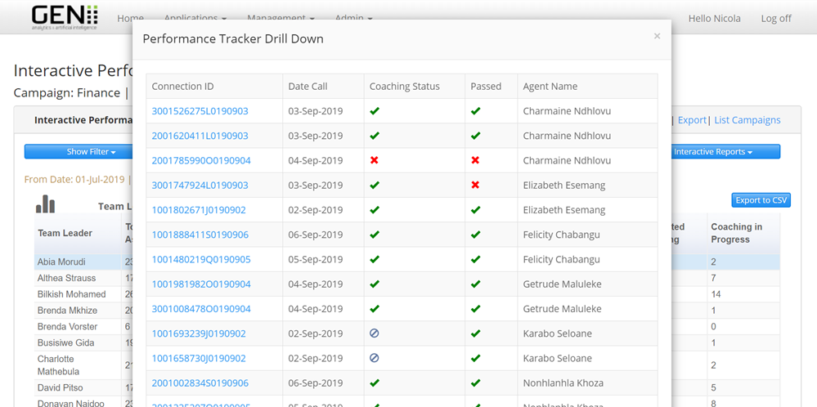

Add the feedback for the interaction if there is none, it will need to be updated before an email can be sent

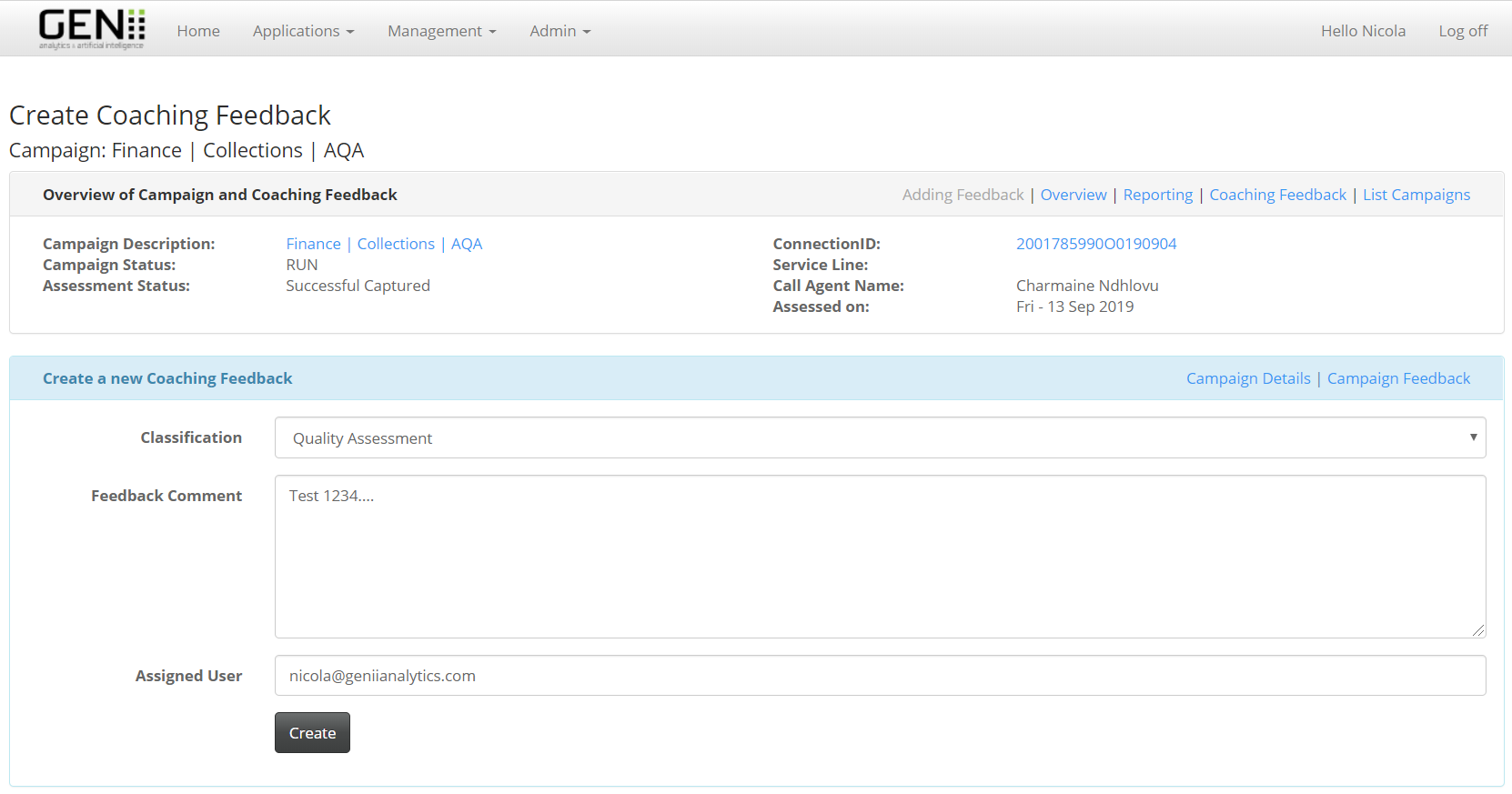

Now follow **Step 1 – 5** on Page 6…

* Overview

Select *Audit* of the applicable interaction

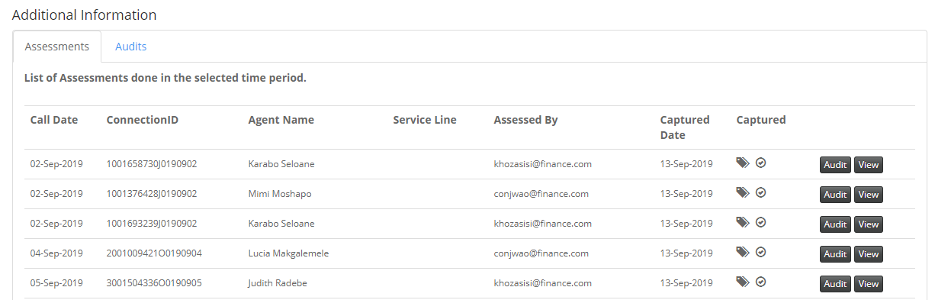

Select *Feedback*

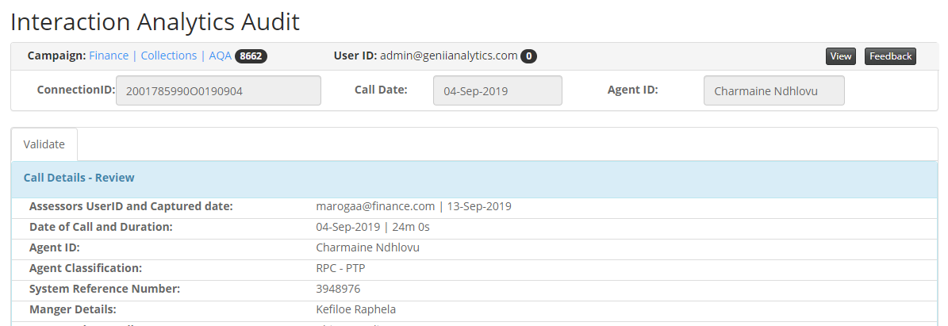

If there is no feedback assigned, it will need to be updated before an email is sent

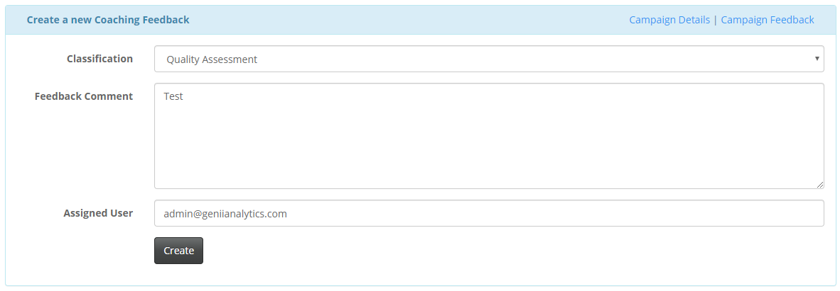

Now follow **Step 1 – 5** on Page 6…

* Agent Detailed PDF Report

Access the Agent Detail PDF Report via the *Reporting* option of the relevant campaign (filter either by your team or for an agent and for the selected period)

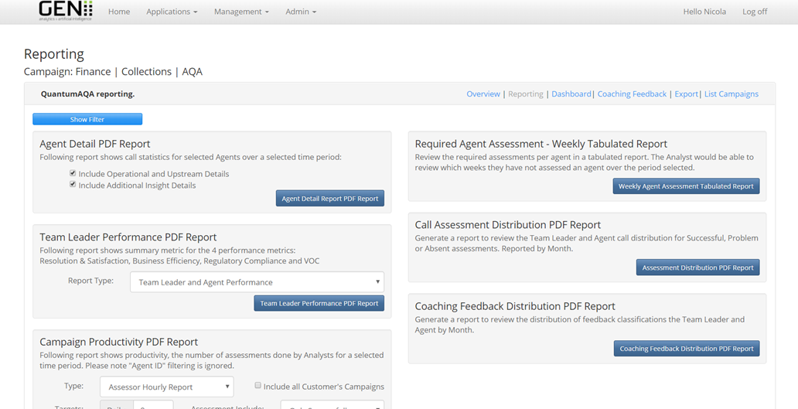

In the coaching PDF select *Review* on the interaction you would like to provide coaching feedback on

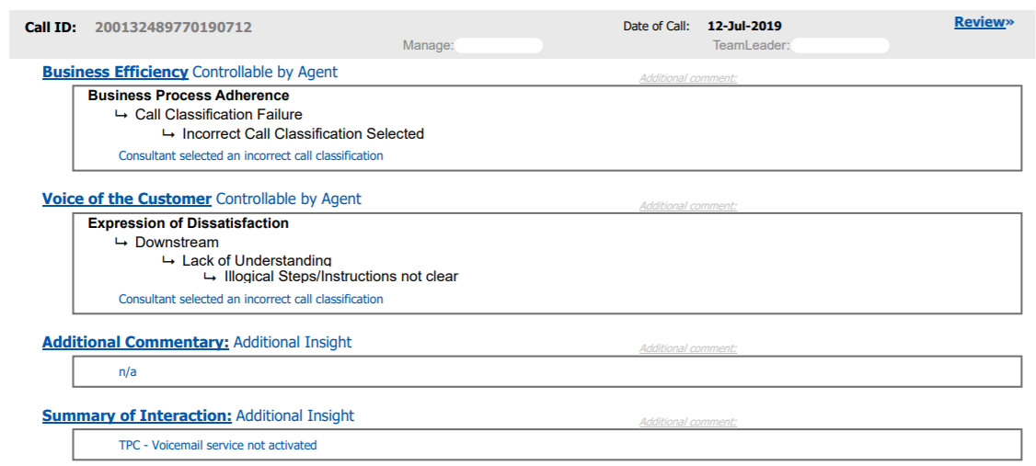

Add the feedback for the interaction if there is none, it will need to be updated before an email can be sent



Now follow **Step 1 – 5** on Page 6…

**Step 1:** You will then select *Send Agent Coaching Report* and a window will pop-up

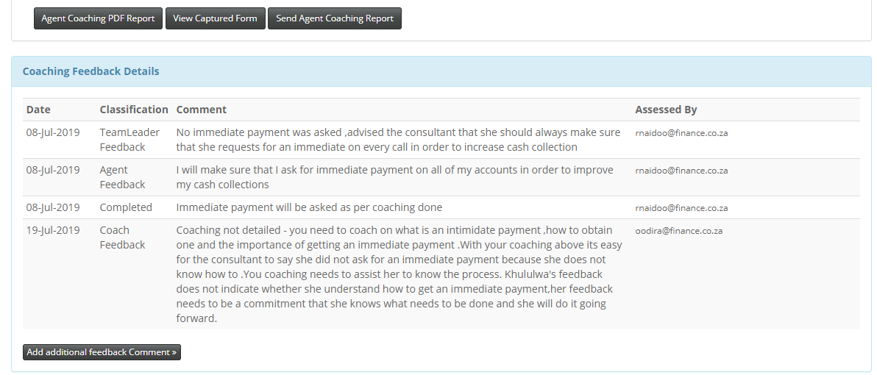

**Step 2:** Enter the agent’s email address to the *Recipient Email* box and select *Submit*

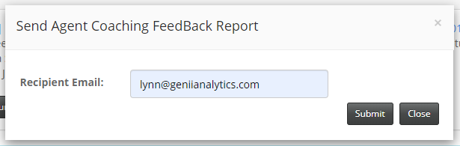

You will receive the following acknowledgement notification.

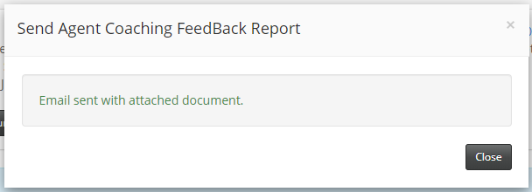

**Step 3:** The agent will receive the following email which will include a pdf report and a link to submit feedback

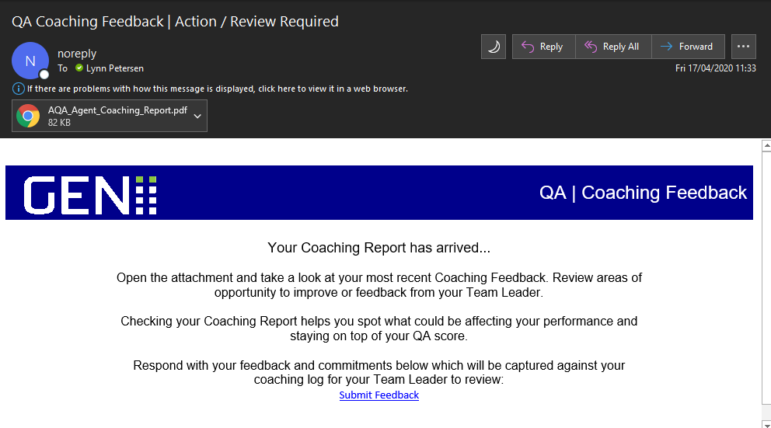

**Step 4:** Once they have selected the link they will be redirected to a secure website where they can submit their comments by adding their notes and selecting *Submit Feedback*

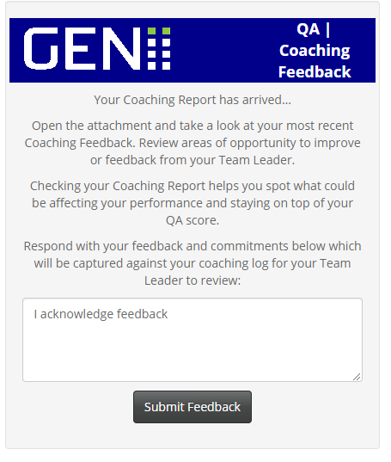



They will get the following acknowledgement notification.

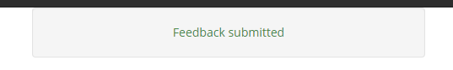

This link will only allow for one submission and if it is accessed again the following notification will come up.



**Step 5:** Once feedback is submitted the app will update accordingly.

